
CAPSTONEPROJECTREPORT Report 3 – Software Requirement Specification
– Da Nang, May 2026 –
1
Table of Contents
• Product Overview .................................................................................................................. 4 1.1 Context Diagram .............................................................................................................. 4 1.2 Main Workflows ............................................................................................................... 6 1.2.1 Register to become company .................................................................................... 6 1.2.2 Find A product ................................................................................................................. 7
• User Requirements ................................................................................................................. 2.1 Actors ............................................................................................................................... 8 2.2Use Cases ........................................................................................................................ 9 2.2.1Diagram(s) .............................................................................................................. 9 2.2.2Descriptions use case ............................................................................................ 15
• Functional Requirements ..................................................................................................19 3.1 System Functional Overview ......................................................................................... 19 3.1.1 Screens Flow ........................................................................................................... 19 3.1.2 Screen Descriptions ................................................................................................. 20 3.1.3 Screen Authorization ............................................................................................... 24 3.1.4 Non-Screen Functions ............................................................................................. 25 3.1.5 Entity Relationship Diagram ................................................................................... 26
• Detailed Use Cases (Agri Platform) ................................................................................27 4.1 Upload Farm Product ..................................................................................................... 27 4.2 Search & View Product Detail ...................................................................................28 4.3 Place Order ..................................................................................................................... 28 4.4 Approve Products Before Display ............................................................................29 4.5 Update Order Status .......................................................................................................
• Requirement Appendix ...................................................................................................69 5.1 Business Rules ............................................................................................................... 69 5.2 Application Messages List ............................................................................................. 70
3
II. Software Requirement Specification
1. Product Overview
1.1 Context Diagram
Agrimarket is a modern agricultural e-commerce platform designed to improve how Farmers and Customers connect and trade. While traditional agricultural supply chains are often long, complex, and reliant on middlemen, Agrimarket uses a direct C2C/B2C model and smart features to create a transparent, fresh, and personalized shopping experience for everyone.
Our platform helps Farmers post their harvested goods, reach a wider market, and manage their sales and orders more easily. At the same time, Customers can search for fresh produce, buy directly from the source, and enjoy high-quality agricultural products with full traceability.
Agrimarket supports secure logins using email, phone numbers, or social media (Google, Facebook). Users are verified to ensure account safety and platform trust. The platform offers an easy-to-use interface, helping Customers search for products by category, keywords, price, and harvest date. They can add items to their cart, securely check out, and track their shipments and delivery status in real-time.
Customers can also engage with modern shopping features such as pre-ordering upcoming harvests or buying directly through interactive Livestreams. Farmers are equipped with powerful management tools to create discount campaigns, manage stock, and process orders efficiently. The platform integrates direct messaging and a dual-review system (evaluating both the product and the farmer) to build trust and long-term relationships between buyers and sellers.
Admins have full access to manage the system. They can approve or remove content, handle user reports (regarding products or behavior), manage support requests, send notifications, and view platform statistics. With these tools, they keep Agrimarket a safe, fair, and reliable marketplace for everyone.
Agrimarket is designed to make trading agricultural products easier and more transparent. Whether you are a Farmer looking to grow your business and increase your income, or a Customer seeking the freshest produce, Agrimarket gives you the tools to support sustainable agriculture and healthy living.
5
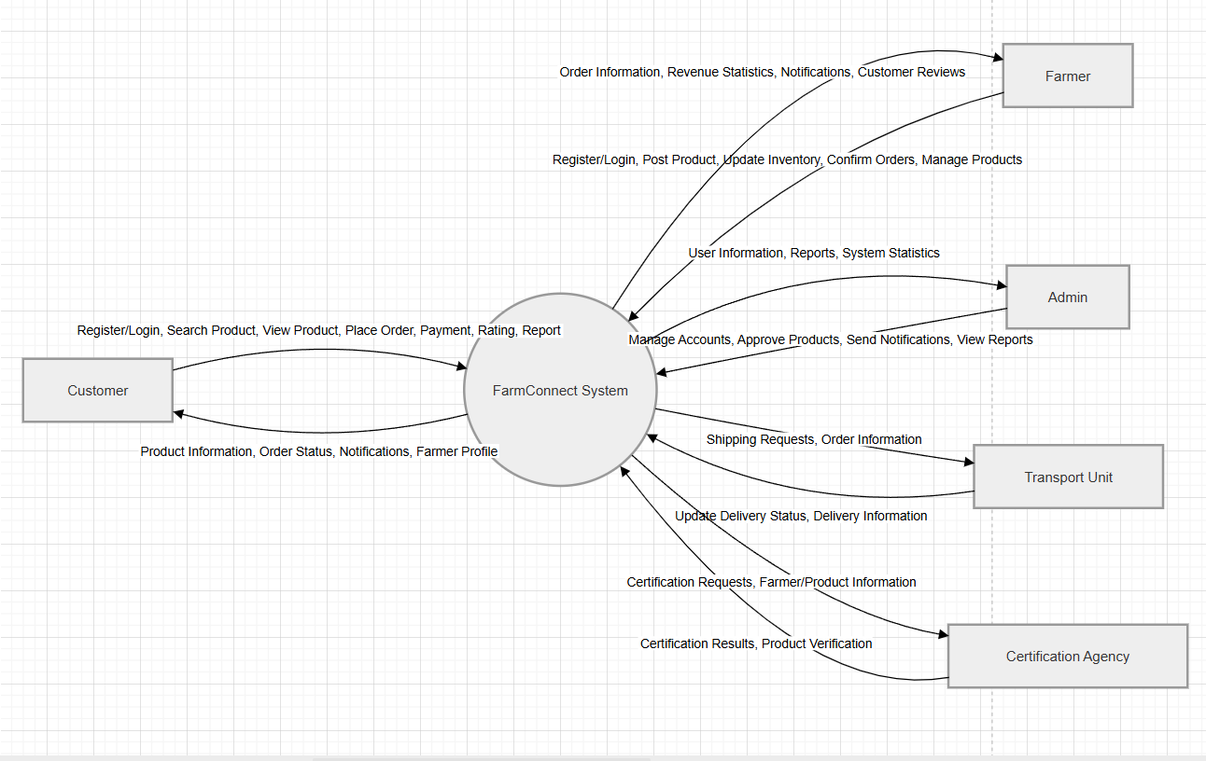Figure 1: Context Diagram for the system
6
1.2 Main Workflows
1.2.1 Register to become company
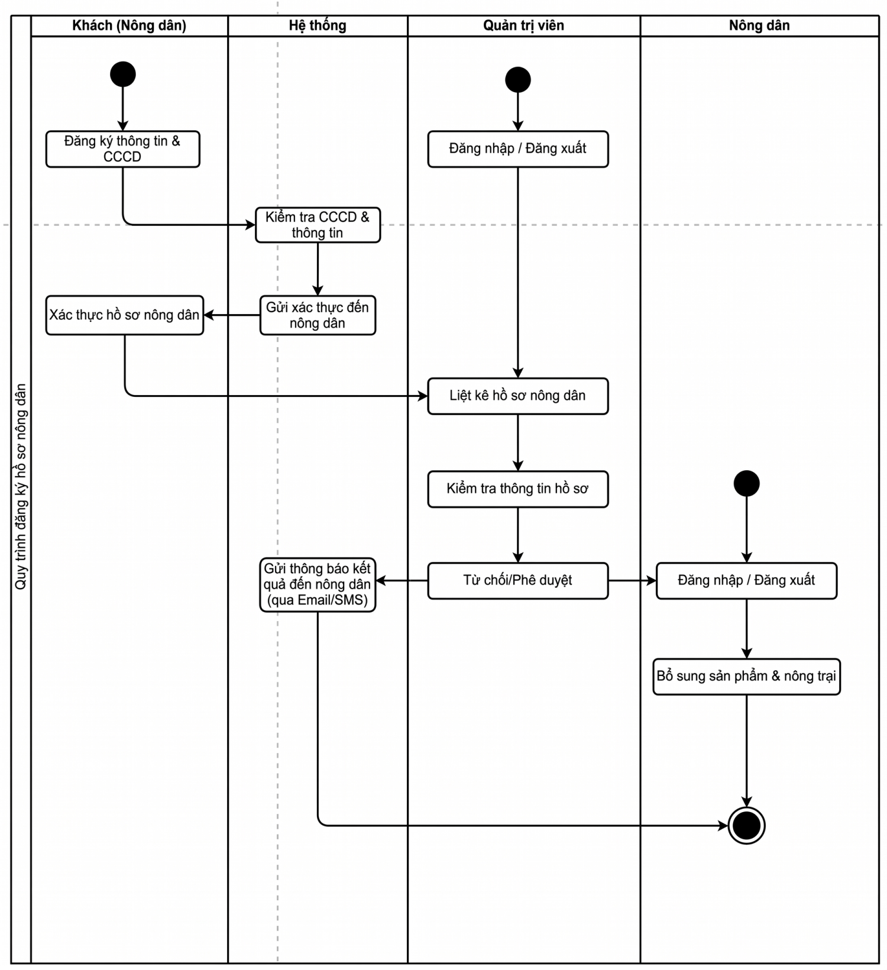Figure 2: Work Flow of Register To Become Farmer.
7
1.2.2 Find A Job
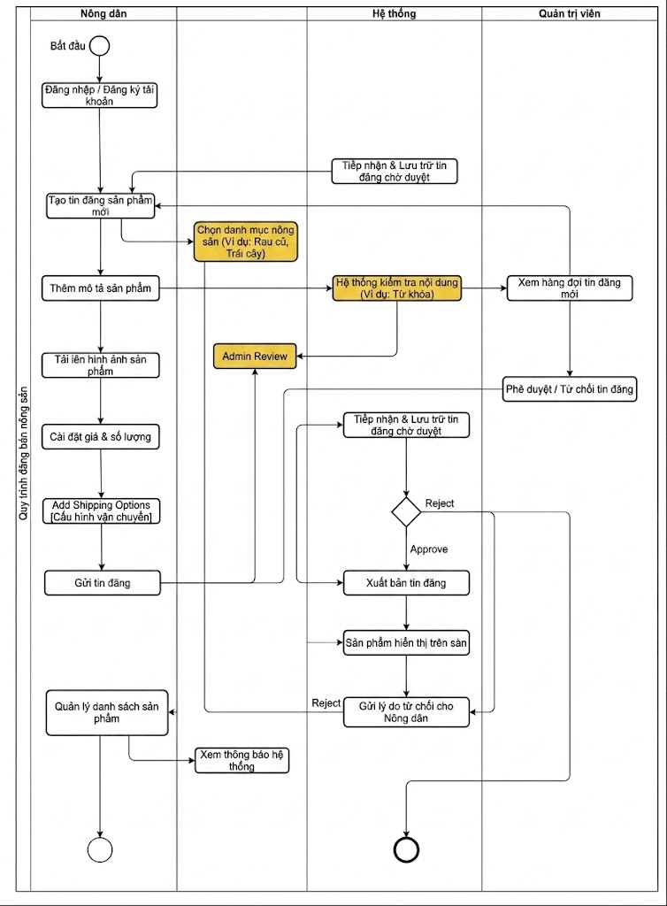Figure 3: Work Flow Of
Link of work flow: Find a Job
8
2. User Requirements
2.1 Actors
# | Actor | Description
1 | Admin | The highest authority in the platform, responsible for managing the entire agricultural marketplace system.  - Has authority to manage users, products, orders, and transactions.  - Can approve or remove product listings from farmers.  - Monitors delivery activities and handles customer complaints/support requests.  - Has authority to manage system reports, categories, and platform settings.
2 | Farmer | Farmers are sellers who use the platform to post and sell agricultural products such as vegetables, fruits, rice, seafood, and other farm products.  - Can create, update, and delete product listings.  - Can manage inventory, prices, and product images.  - Can receive and process customer orders.  - Can track sales history and revenue.
3 | Customer | Customers are users who use the platform to search for and purchase agricultural products from farmers.  - Can search and view product information.  - Can place orders, make payments, and track deliveries.  - Can rate products and provide feedback after purchase.  - Can manage personal profile and order history.
4 | Transpory  Unit | Transport Units are logistics partners responsible for transporting products from farmers to customers.  - Can view assigned delivery orders.  - Can update delivery status such as packing, shipping, and delivered.  - Can manage delivery schedules and shipping information.
 | Guest | A guest is a visitor who accesses the platform without logging in.  - Can browse products and view basic product information.  - Must register or log in to place orders or use advanced features.

Table 1: Actor description
9
2.2 Use Cases
2.2.1 Diagram(s)
2.2.1.1.Customer use case diagram
z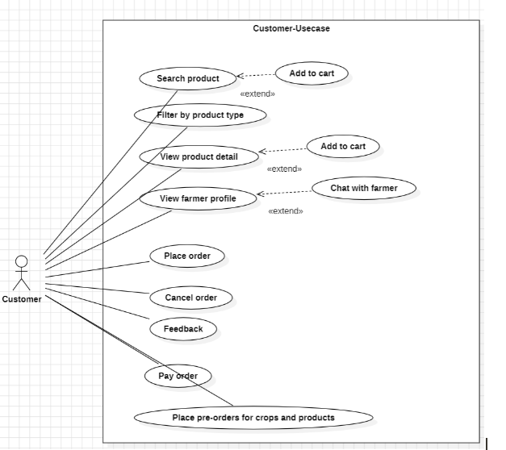
Figure 4: Use case for Customer
10
2.2.1.2. Farmer use case diagram

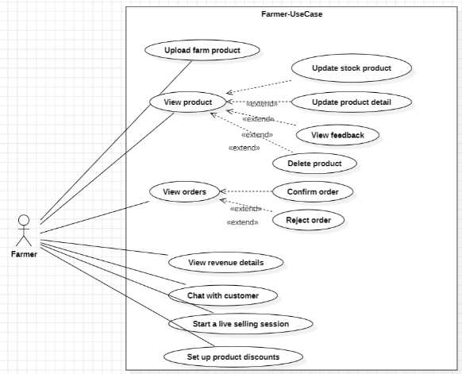
Figure 5: Use case Farmer

2.2.1.3. Use Case for User
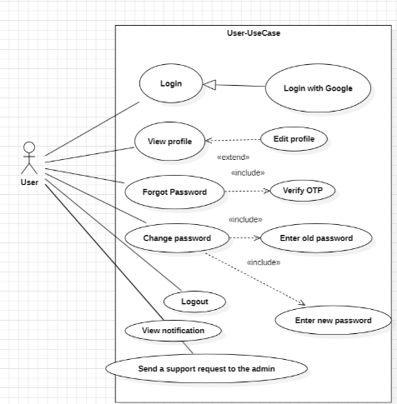
Figure 6: Use case diagram for User
12
2.2.1.4. Use Case for Admin
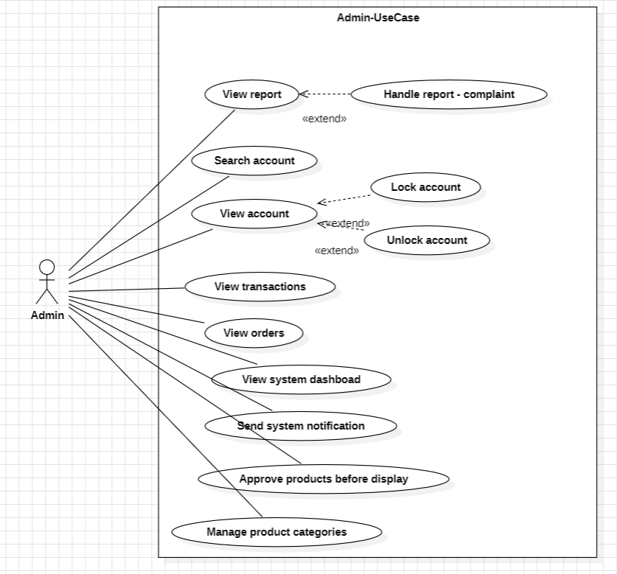Figure 7: Use case diagram for Admin.
13
2.2.1.5. Use Case for TransportUnit.
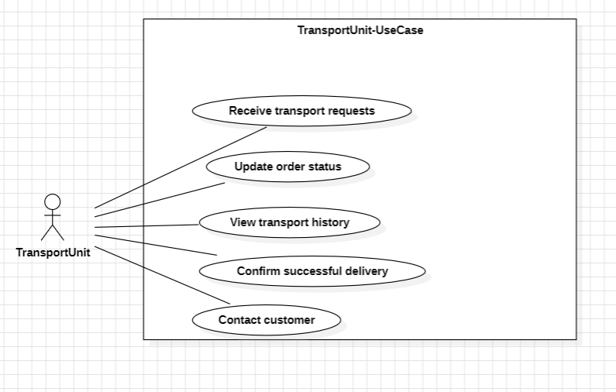Figure 8: Use case diagram for Transport Unit
14

15
2.2.2 Descriptions use case

ID | Use Case | Actors | Use Case Description
UC-01 | Login | User | User logs into the system (includes logging in with Google).
UC-02 | View profile | User | User views their personal profile. Can be extended to Edit profile.
UC-03 | Forgot Password | User | User initiates password recovery. Includes the mandatory step to Verify OTP.
UC-04 | Change password | User | User changes their password. Includes mandatory steps to Enter old password and Enter new password.
UC-05 | Logout | User | User logs out of the system.
UC-06 | View notification | User | User views system notifications.
UC-07 | Send a support request to the admin | User | User sends a support request to the administrator.
UC-08 | Upload farm product | Farmer | Farmer uploads new agricultural products to the system.
UC-09 | View product | Farmer | Farmer views their product list. Can be extended to Update stock product, Update product detail, View feedback, or Delete product.
UC-10 | View orders | Farmer | Farmer views customer orders. Can be extended to Confirm order or Reject order.
UC-11 | View revenue details | Farmer | Farmer views detailed revenue from sales.
UC-12 | Chat with customer | Farmer | Farmer messages directly with a customer.
UC-13 | Start a live selling session | Farmer | Farmer starts a live selling session (livestream) to sell products.
UC-14 | Set up product discounts | Farmer | Farmer sets up discounts and promotions for their products.
UC-15 | Search product | Customer | Customer searches for products. Can be extended to Add to cart.
UC-16 | Filter by product type | Customer | Customer filters the product list by specific categories.
UC-17 | View product detail | Customer | Customer views detailed information of a product. Can be extended to Add to cart.
UC-18 | View farmer profile | Customer | Customer views a farmer's profile. Can be extended to Chat with farmer.
UC-19 | Place order | Customer | Customer places an order for items in their cart.
UC-20 | Cancel order | Customer | Customer cancels a placed order.
UC-21 | Feedback | Customer | Customer sends feedback or reviews about a product or service.
UC-22 | Pay order | Customer | Customer makes a payment for their order.
UC-23 | Place pre-orders for crops and products | Customer | Customer places pre-orders for crops and agricultural products before harvest.
UC-24 | View report | Admin | Administrator views reports. Can be extended to Handle report - complaint.
UC-25 | Search account | Admin | Administrator searches for user account information.
UC-26 | View account | Admin | Administrator views account details. Can be extended to Lock account or Unlock account.
UC-27 | View transactions | Admin | Administrator views the history of payment transactions on the system.
UC-28 | View orders | Admin | Administrator monitors and views all system orders.
UC-29 | View system dashboard | Admin | Administrator views the general statistical dashboard of the system.
UC-30 | Send system notification | Admin | Administrator sends notifications to users on the system.
UC-31 | Approve products before display | Admin | Administrator reviews and approves products before they are allowed to be displayed.
UC-32 | Manage product categories | Admin | Administrator manages (adds, edits, deletes) product categories.
UC-33 | Receive transport requests | TransportUnit | Transport unit receives requests for delivery.
UC-34 | Update order status | TransportUnit | Transport unit updates the current status of an order.
UC-35 | View transport history | TransportUnit | Transport unit views the history of their assigned deliveries.
UC-36 | Confirm successful delivery | TransportUnit | Transport unit confirms when an order is successfully delivered to the customer.
UC-37 | Contact customer | TransportUnit | Transport unit contacts the customer to coordinate delivery.

3.1 System Functional Overview
3.1.1 Screens Flow
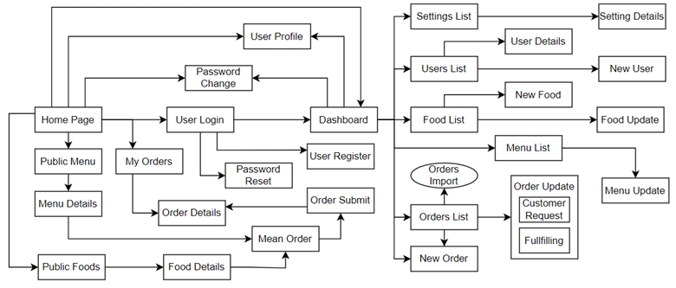
20
3.1.2 Screen Descriptions
# | Feature | Screen | Description
1 | Landing Page | Landing Page | Initial entry point for users visiting the platform.
2 | Authentication | Sign In | Login screen for all user roles (Customer, Farmer, Admin, Transport Unit).
3 | Authentication | Sign Up | Registration screen for new users.
4 | Authentication | Forgot Password | Password recovery and OTP verification screen.
5 | User Management | User Profile | Screen to view and edit personal information and settings.
6 | Communication | Notifications | Screen displaying system and transaction notifications.
7 | Customer Home | Home Page | Main workspace for customers to discover agricultural products.
8 | Product Discovery | Search & Filter | Screen to search products and apply category filters.
9 | Product Discovery | Product Detail | Detailed view of a specific product, including price, stock, and reviews.
10 | Product Discovery | Farmer Profile | Screen showing a farmer's details, product list, and ratings.
11 | Order Management | Shopping Cart | Screen to review selected items before checkout.
12 | Order Management | Checkout | Screen to enter shipping details, choose payment method, and place order.
13 | Order Management | Order History | Screen for customers to track current and past orders.
14 | Communication | Chat | Messaging interface for real-time communication between users.
15 | Farmer Workspace | Farmer Dashboard | Main dashboard for farmers showing sales overview and quick actions.
16 | Farmer Operations | Product Management | Screen for farmers to upload, update, and delete their agricultural products.
17 | Farmer Operations | Order Management | Screen for farmers to view, confirm, or reject incoming customer orders.
18 | Farmer Operations | Revenue Details | Screen displaying detailed financial reports and sales revenue for the farmer.
19 | Farmer Operations | Live Selling | Interface for farmers to conduct live streaming sessions to sell products.
20 | Farmer Operations | Discount Management | Screen to set up and manage product promotions and discounts.
21 | Admin Workspace | Admin Dashboard | Main dashboard for administrators displaying system statistics and overview.
22 | Admin Operations | Account Management | Screen for administrators to search, view, and lock/unlock user accounts.
23 | Admin Operations | Product Approval | Screen to review and approve newly uploaded products before displaying them.
24 | Admin Operations | Category Management | Screen to add, edit, or delete product categories.
25 | Admin Operations | Reports & Transactions | Screen to view system reports, complaints, and transaction history.
26 | Transport Workspace | Transport Dashboard | Main workspace for transport units to view current delivery status.
27 | Transport Operations | Delivery Requests | Screen to view and accept pending transport requests.
28 | Transport Operations | Delivery History | Screen detailing past successful and failed deliveries.

Table 3: Screen description
3.1.3 Screen Authorization
Screen | Guest | Customer | Farmer | Admin | Transport Unit
Authentication (Sign In/Sign Up) | X
Password Recovery | X
Home Page / Landing Page | X | X
Search & View Products | X | X
View Farmer Profile | X | X
User Profile |  | X | X | X | X
Notifications |  | X | X | X | X
Chat / Messaging |  | X | X |  | X
Shopping Cart & Checkout |  | X
Customer Order History |  | X
Farmer Dashboard |  |  | X
Product Management |  |  | X
Farmer Order Management |  |  | X
Revenue Details |  |  | X
Live Selling |  |  | X
Discount Management |  |  | X
Admin Dashboard |  |  |  | X
Account Management |  |  |  | X
Product Approval |  |  |  | X
Category Management |  |  |  | X
Reports & Transactions |  |  |  | X
Transport Dashboard |  |  |  |  | X
Delivery Requests |  |  |  |  | X
Delivery History |  |  |  |  | X

Table 4: Screen Authorization
25
3.1.4 Non-Screen Functions
# | Feature | System  Function | Description
1 | Authorization | Function for User | All requests to Candidate, Company and Admin functions are passed through the user authorization middleware.
2 | WebSocket  Connection | Connection | Establishes real-time communication for instant notifications and updates between users and the system.
3 | Push  Notifications | Notify users | Sends real-time notifications about ride status, payment confirmations, promotions, and important updates.

Table 5: Non-screen functions

3.1.5 Entity Relationship Diagram
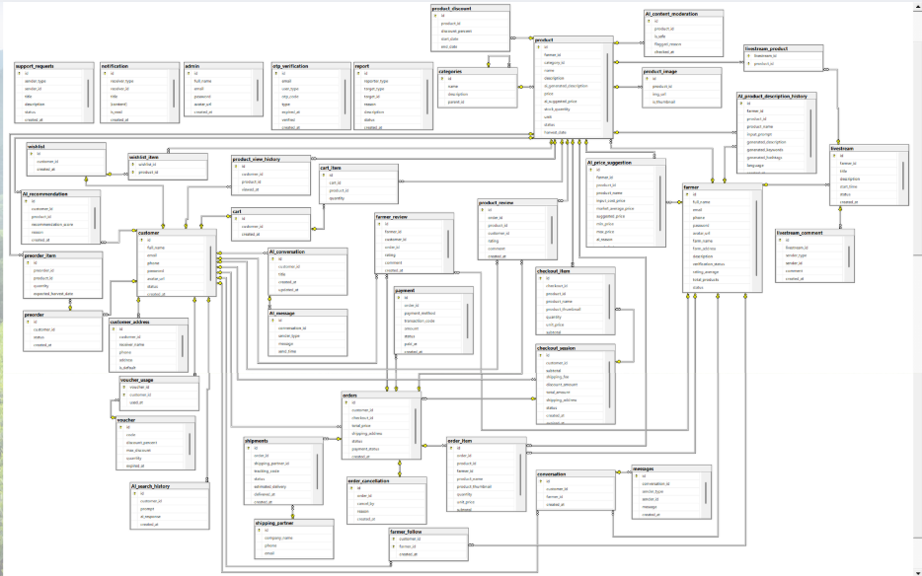
Figure 13: Entity Relationship diagram
26

Entities Description
# | Entity | Description
1 | Users | Stores user-related data, including email, password, roles, and verification status.
2 | Candidate Profile | Stores candidate-specific details like education and personal descriptions.
3 | CV | Contains uploaded CVs with content, titles, PDF links, and sharing information.
4 | Company | Company data including name, industry, tax code, and business license info.
5 | Job | Job postings with details such as title, salary, experience, and location.
6 | Job Application | Represents user applications to jobs, including status and attached CVs.
7 | Calendar | Schedules or appointments related to users, such as interviews or meetings.
8 | Payment | Records user payments for packages, coupons used, and transaction status.
9 | Package | Information about service plans users can purchase, like job posting packages.
10 | Coupon | Discount codes applicable to payments, with expiration and activation status.
11 | Notification | System-generated alerts for updates, messages, or actions taken on the platform.
12 | Chat | Stores 1:1 message exchanged between users (e.g., candidate and company).
13 | Candidate Roadmap | Tracks candidate progress in job applications through roadmap steps.

Table 6: Entity Description
27

4.Detailed Use Cases (Agri Platform)
4.1 Upload Farm Product
Function Trigger: Farmer accesses the dashboard and selects “Upload Product”.
Function Description: The Farmer fills in required information (Product name, category,
description, quantity, unit price, harvest date, images). Upon submission, the product is
sent to the Admin for approval before becoming visible to Customers on the platform.
Actors/Roles: Farmer
Interface Elements
• “Upload Product” button.
• Form fields: Product name, Category, Description, Quantity, Unit Price, Harvest
Date.
• Image upload area for product pictures.
• Toast/notification on success or failure.
Data Processing
Input:
• Product data from the form.
• Uploaded image files.
Processing:
• Validate required fields and image formats.
• Save product data to the database.
• Set default status to “Pending Approval”.
Output:
• Product appears in the Farmer&#39;s product list with &#39;Pending&#39; status.
• Notification sent to Admin for review.
• UI updates with success notification.
Business Rules (BR):
• All required fields must be filled.
• Only authenticated Farmers can upload products.
• Products must be approved by an Admin before being displayed to Customers.

Error Handling:
• Missing fields → form validation error.
• Invalid image format/size → error message.
• Network/server issues → general error notification.

4.2 Search &amp; View Product Detail
Function Trigger: Customer accesses the Home Page and enters keywords in the search
bar or applies filters.
Function Description: The Customer searches for agricultural products using keywords,
categories, or price filters. Selecting a product from the results opens the detail page,
displaying the product&#39;s price, farmer profile, stock availability, and reviews.
Actors/Roles: Customer
Interface Elements
• Search bar and Filter dropdowns (Category, Price range, Location).
• Product list/grid view.
• Product detail page containing descriptions, images, and Farmer info.
• “Add to Cart” button.
Data Processing
Input:
• Search keywords, selected filters.
• Selected Product ID.
Processing:
• Query the database for products matching the criteria and with &#39;Approved&#39; status.
• Fetch and display detailed information for the selected product.
Output:
• Filtered list of products.
• Detailed product view.
• Recommended/related products.
Business Rules (BR):

• Only &#39;Approved&#39; and &#39;Active&#39; products are displayed.
• Guests can search and view products, but must log in to add to cart.
Error Handling:
• No products found → display &#39;No results match your criteria&#39;.
• Product out of stock → disable &#39;Add to Cart&#39; button.

4.3 Place Order
Function Trigger: Customer navigates to the Shopping Cart and clicks “Checkout”.
Function Description: The Customer reviews selected items, enters delivery
information, and chooses a payment method. The system calculates the total cost
including shipping, processes the payment, and creates the order.
Actors/Roles: Customer
Interface Elements
• Shopping cart review list.
• Form fields: Delivery Address, Contact Number, Note.
• Payment method selection (e.g., VNPay, COD).
• “Place Order” button.
Data Processing
Input:
• Cart items.
• Delivery address and contact info.
• Payment selection.
Processing:
• Validate stock availability for all cart items.
• Calculate total price and shipping fees.
• Process payment (if online).
• Create order records in the database.
• Clear purchased items from the cart.
Output:
• Order confirmation screen with Order ID.

• Notifications sent to the Customer, Farmer, and Transport Unit.
Business Rules (BR):
• Customer must be logged in.
• Order cannot be placed if stock is insufficient.
• Online payment must be verified before order status is set to &#39;Confirmed&#39;.
Error Handling:
• Payment failed → redirect to retry payment.
• Item out of stock during checkout → prompt user to update cart.
• Missing delivery info → validation error.

4.4 Approve Products Before Display
Function Trigger: Admin accesses the &#39;Product Approval&#39; section from the dashboard.
Function Description: The Admin reviews products uploaded by Farmers to ensure they
meet platform quality and policy standards. The Admin can approve the product for
display or reject it with a specific reason.
Actors/Roles: Admin
Interface Elements
• List of &#39;Pending&#39; products.
• Product detail view (images, descriptions, price).
• “Approve” and “Reject” buttons.
• Input field for rejection reason.
Data Processing
Input:
• Product ID.
• Admin action (Approve/Reject).
• Rejection reason (if applicable).
Processing:
• Update product status in the database (&#39;Approved&#39; or &#39;Rejected&#39;).
• Trigger notification to the corresponding Farmer.

Output:
• Updated product status.
• Product becomes visible to Customers (if approved).
• System notification to the Farmer.
Business Rules (BR):
• Only Admins have the authority to approve/reject products.
• Rejected products must include a clear reason for the Farmer.
Error Handling:
• Database update failure → display error and retry.
• Action performed without selecting a product → validation warning.

4.5 Update Order Status
Function Trigger: Transport Unit accesses the &#39;Delivery Requests&#39; or &#39;Active Deliveries&#39;
screen.
Function Description: The Transport Unit updates the real-time status of an assigned
order (e.g., &#39;Picked up&#39;, &#39;In Transit&#39;, &#39;Delivered&#39;). This provides tracking transparency for
both the Customer and the Farmer.
Actors/Roles: Transport Unit
Interface Elements
• List of assigned orders.
• Status update dropdown/buttons.
• Image upload for proof of delivery (optional).
• “Confirm Update” button.
Data Processing
Input:
• Order ID.
• New status.
• Proof of delivery (image/signature).
Processing:

• Validate the status transition (e.g., cannot jump from &#39;Pending&#39; directly to &#39;Delivered&#39;
without &#39;In Transit&#39;).
• Update order status in the database.
• Send notifications to Customer and Farmer.
Output:
• Updated status visible on all relevant dashboards.
• Notifications dispatched.
• Delivery history updated.
Business Rules (BR):
• Transport Unit can only update orders assigned to them.
• &#39;Delivered&#39; status requires confirmation or proof of delivery.
• Status updates follow a predefined chronological flow.
Error Handling:
• Invalid status transition → error message.
• Network timeout → prompt to retry update.
69
5. Requirement Appendix
5.1 Business Rules
ID | Category | Rule Definition
BR-01 | Email validation rule | Email must follow correct email format and must be unique in the users table
BR-02 | Password validation rule | Password must contain at least 8 characters
BR-03 | Login validation rule | User must input correct email and password
BR-04 | Account status rule | User with status banned cannot login
BR-05 | Google Authentication Rule | Users must authenticate using a valid Google account through Google Authentication service.
BR-6 | Session Management Rule | System must clear all active session data after user logout.
BR-7 | Secure Access Rule | Unauthorized users cannot access authenticated features without logging in.
BR-09 | Support Request Validation | The system must require users to fill in all mandatory support request fields before submission.
BR-10 | Support Content Validation | The system must reject support requests containing invalid, empty, or too-short content.
BR-11 | Product Information Validation | The system must require farmers to provide all mandatory product information fields before posting products.
BR-12 | Product Price Validation | The system must only allow product prices greater than 0.
BR-13 | Product Image Validation | The system must only accept supported image formats and file sizes within the allowed limitation.
BR-14 | User Profile | Users can only edit their own profile. The system will display a message such as MSG14 or MSG15.
BR-15 | User Profile | Profile information must be retrieved based on authenticated user. If not, the MSG16 message will be displayed.
BR-33 | Password security rule | Reset password token expires after limited time
BR-37 | Password encryption rule | Passwords must be encrypted before saving into database

Table 7: Business Rules
70
5.2 Application Messages List
# | Message Code | Message Type | Context
1 | MSG_07 | Succes | Password updated and committed into system records safely
2 | MSG_ERR_07 | Error | User input for the current password does not match DB
3 | MSG_08 | Success | Database transaction committed successfully updating account entry
4 | MSG_ERR_OTP_INVALID | Error | User input token is mathematically incorrect
5 | MSG09 | Error | User submits support request form with missing required fields
6 | MSG10 | Error | User submits support request with invalid or too short content
7 | MSG11 | Error | Farmer submits product form with empty required fields
8 | MSG12 | Error | Farmer enters product price less than or equal to 0
9 | MSG13 | Error | Farmer uploads unsupported image format or oversized image
10 | MSG14 | Success | Users edit profile
11 | MSG15 | Error | Users edit profile
12 | MSG16 | Warning | Users are viewing profiles that are not their own.
# | Message Code | Message Type | Context
1 | MSG_07 | Succes | Password updated and committed into system records safely

Table 8: Application Messages
71

